Ideation Phase Empathize &amp; Discover
Date | 24 September 2026
Team ID | SWTID-2026-6228
Project Name | AI-Blog Nest API
Maximum Mark | Marks

Empathy Map Canvas
An empathy map is a simple visual tool used to understand a user’s thoughts, feelings, actions, and experiences.
It helps a team gain a better understanding of the people they are designing a product or service for. By looking at the user’s point of view, the team can identify their needs, expectations, difficulties, and goals.
Creating an empathy map encourages team members to think from the user’s perspective. This helps them understand the actual problem and develop solutions that are more useful and suitable for the user.
Example:
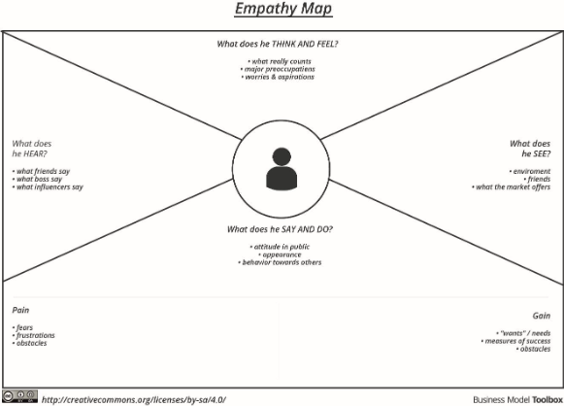

Example: Food Ordering &amp; Delivery Application
